Student’s name | …………………………………………………….…… | Grade | 4
Subject | Computer | Week No. | 2
Lesson Title | Retouch Images | Unit
Worksheet No. ( 2 )
Question A: Write the correct name of each part.

After retouch | Vector | Before retouch
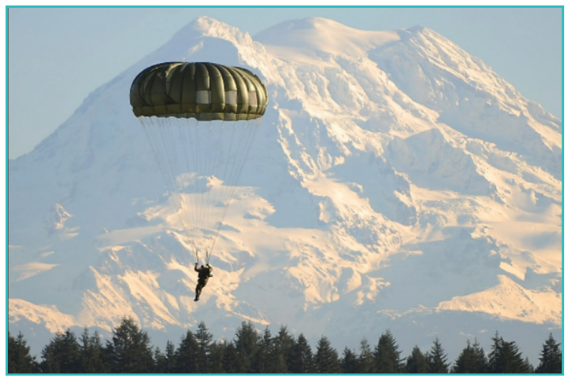
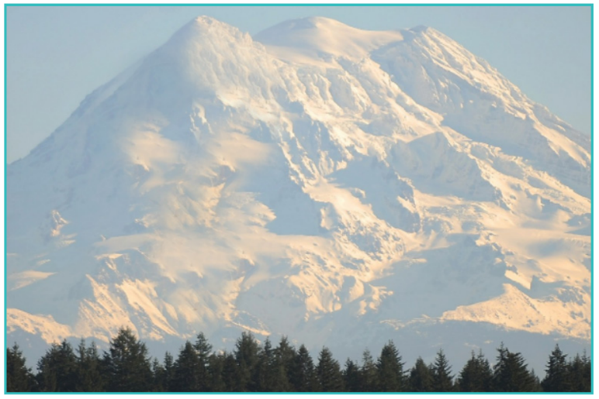
Good Luck

